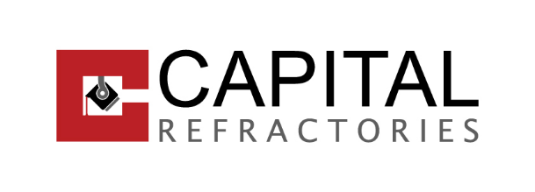We are a major manufacturer of products that we supply to our customers not only from the Czech Republic, but also from European and other countries around the world. We are passionate about creating products that offer maximum utility and exceed expectations. In the future we want to continue on this path and bring only the best to our customers!

The management is fully aware of the growing demands and expectations of our customers! We are committed to delivering products of the highest possible quality, on time, in the right quantity and at competitive prices - all with respect for the environment.

To achieve these ambitious goals, we have implemented an integrated Quality Management System (QMS) and Environmental Management System (EMS) to ensure the continued delivery of these commitments. As a testament to our unwavering commitment to being a leader in quality and sustainability, the following is announced:

**INTEGRATED MANAGEMENT SYSTEM POLICY**

which is promoted through policies in the following areas:

**Customers**

- build long-term and mutually beneficial partnerships with customers

- deliver the ordered quantity within the agreed time and in the required quality

**Suppliers**

- build long-term and mutually beneficial partnerships with suppliers

- implement transparent tendering procedures with regard to climate change

**Staff**

- to promote the development of staff competence to achieve a high level of quality work with regard to the protection of the working environment

- to protect the health of employees and the environment, to prevent accidents and emergency situations by effective prevention

**Technology and infrastructure**

- actively support the introduction of new technologies that will benefit our customers and our organisation

- optimise the logistical flows of materials and products in the organisation with regard to climate change

**Surrounding environment**

- to actively cooperate with state bodies, organisations and local authorities operating within the company's reach

- to participate in sponsoring public benefit activities within the scope of its competence

- reduce the risk of damage to the surrounding environment

**The company's management is committed to:**

- adhere to the above principles

- meet the requirements of EU regulations, laws and implementing legislation

- continuously improve the quality and environmental management system

Mgr. Tomasz Janas, MBA; Managing Director